**A World Without Fritz Haber**

Final Project Proposal

Group C: Kami Wang, Yihan Chen, Michael Cornell

**Concept.**

Our reimagined history plays out as societies struggle with famine. Fritz Haber’s absence reshaped the twentieth century. Without the Haber–Bosch process, humanity never learned to pull nitrogen from the air and convert it into synthetic fertilizer. Agriculture remained tied to natural fertilizers and limited yields. By the 1930s, the promise of abundance collapsed: global populations fell under relentless famine. Governments ration what little they could, while scientists raced to invent substitutes — pills, pastes, injections that provided only the bare minimum nutrients to survive. Even with eating replaced, hunger remained. The populace thus lives in a constant state of agitation — “growlers,” as they come to be called, technically alive but both hungry and angry. As the social fabric frays, hunger overwhelms any illusion of stability.

In response to these crises, bioengineering produced a new solution: hunger-suppressing implants. By the mid-20th century, states and corporations turned from producing food to pursuing technological control of hunger. In 1972, *Vitalis Systems* released the first *Hunger Regulation Chip* — a subcutaneous implant that monitors metabolism and emits biochemical signals to suppress hunger. The algorithm that powered the chip was designed and controlled by Vitalis. Governments did not build their own systems; instead, they licensed Vitalis’s platform and depended on it to manage public order. Through this arrangement, hunger — and with it mood, behavior, and access to resources — was managed algorithmically. Food itself was reduced to a standardized nutrient paste, distributed at public stations and rationed according to population models, resource availability, and suppression schedules. To address the inevitable failures — the occasional “growlers,” those in volatile states of delirium as a result of hunger or malfunctioning implants — the Hunger Crisis Intervention Taskforce was established in 1985. Unlike police or fire departments, the Taskforce was never a state service. Instead, it functioned as a corporate extension: outfitted, trained, and managed by Vitalis, its technology embedded directly into local governance.

By the 21st century, Taskforce members rely on a computational dashboard that integrates data from across society: implant statistics, patterns of public unrest, caloric stockpile levels, and social media analysis. Even the members themselves are chosen by the *Algorithm*, though no one outside Vitalis truly understands how it works or why it selects whom it does. To the public, the *Algorithm* remains a black box — inscrutable yet absolute. When it detects a flashpoint, the Taskforce intervenes, quelling riots, recalibrating implants, and redistributing nutrient doses — not to decide, but to validate what the *Algorithm* already dictates. Yet when mistakes occur, it is always the humans who bear the blame, never the system that guided them. Over time, eating lost its cultural and social dimensions: to eat was to obey the *Algorithm*. The most personal, bodily aspects of human life — hunger and satisfaction — are no longer sensations but external instructions: *“Consume now.”* *“Stop.”*

**Objectives.**

This counterfactual world ties closely to our present reality. Today, bodies are managed and dehumanized through multiple systems of control: the industrial food complex reduces meals to ultra-processed commodities, stripping away culture and tradition; algorithmic systems from fitness apps to social media engineer behavior through data and dopamine; and institutions police bodily autonomy through responses to drug use, mental health crises, and reproductive health. In our project, hunger condenses these struggles into a single register, showing how basic rhythms of desire and satisfaction can be institutionalized. Just as the Hunger Regulation Chip dictates when one may eat, contemporary systems dictate when and how individuals may seek care, move, or express need. Our project asks: what happens when the management of human desire and suffering becomes purely technical, leaving aside the cultural, social, and political dimensions of being human?

The project also highlights the growing intersection between corporate technology and public governance. Inspired in part by real-world cases where police departments rely on surveillance cameras and analytics built and owned by private companies to monitor the public, our scenario explores how governments come to depend on a proprietary algorithm they neither built nor control. These tools function as black boxes: opaque to citizens, outside democratic oversight, yet central to state power. This dependence mirrors the dynamics of surveillance capitalism: the state cedes authority to corporate infrastructures, while citizens are left in a position of opacity and powerlessness. The result is a system in which human lives are managed by code, yet when errors occur, it is the humans — not the algorithm — who are held responsible.

We invite the audience to step into the role of recruits in the last stage of selection for the Hunger Crisis Intervention Taskforce. Their experience begins with a propaganda video urging citizens to adopt the Hunger Regulation Chip, framing the implant as both a patriotic duty and a personal necessity. From there, the audience is placed inside an interactive training session, guided by a computational dashboard that mirrors the tools used by real Taskforce members. Participants engage directly with simulated alerts — identifying potential “growlers,” monitoring resource distributions, and responding to crises — only to discover that their actions are evaluated and graded by the *Algorithm* itself as a part of their selection process.

This layered experience reinforces our concept by making the audience feel both the immediacy and the limits of their agency. They see how propaganda shapes compliance, how dashboards turn life into data streams, and how opaque algorithms determine outcomes while holding humans responsible. The mix of media — video, posters, dashboard interaction, and role-play — makes the speculative world tangible and immersive, highlighting the unsettling parallels to today’s systems of surveillance, algorithmic governance, and corporate control over public life.

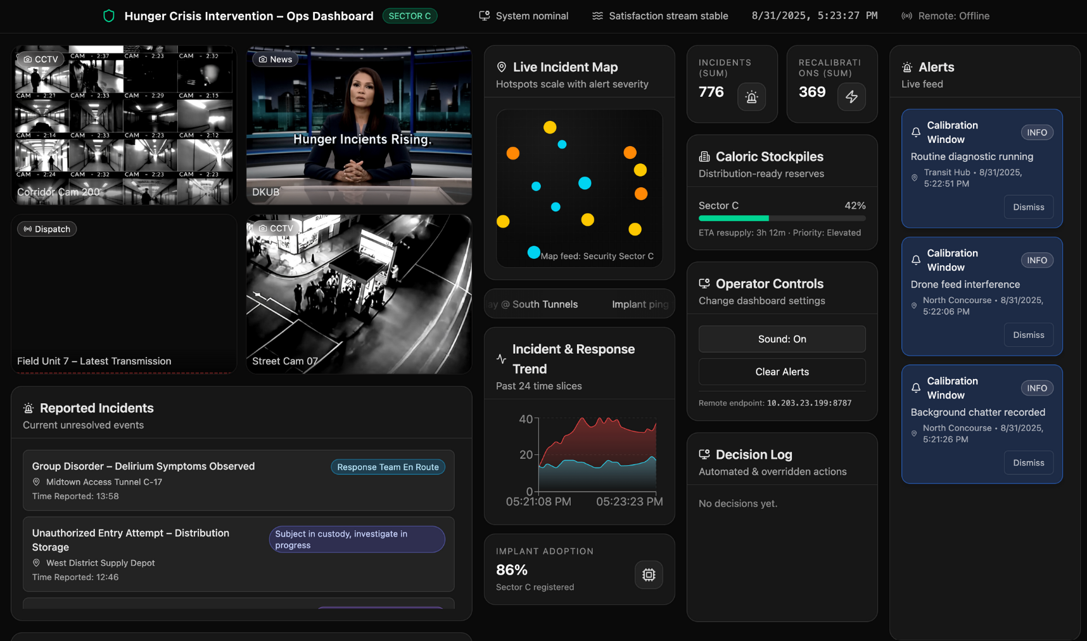

Previous Dashboard Screenshot

**Upgrades.**

Our final project modifies and upgrades our previous presentation. Firstly, our audience didn’t understand what a growler was, or how to identify a growler. To remedy this, we create an informational “How to Spot a Growler” PSA poster. Additionally, we left the population and size of ‘Sector C’ vague, which left viewers curious as to the scale of the taskforce’s response area. To clarify, we add a Sector C population count to the dashboard and mention that the local Taskforce branch responds to an area comparable to a municipality’s police department. We emphasize how Vitalis Systems, the corporation behind this technology, extends its influence into local governance by equipping and shaping the taskforce, which is not a government agency but acts in a similar capacity to police or emergency services. We also add a world population count to ground people in a world without the Green Revolution. Beyond numerical details, we expand on broader aspects of society, including class structure, politics, and economy: for example, highlighting that wealthier citizens can afford higher-quality chips and reliable access to food, while most people have chips of varying quality, and a small minority still live without them. These groups are likely to be “growlers.” In this upgrade, the Algorithm is foregrounded as a watchdog and auditor of all decisions, with taskforce members serving more as a “human stamp of approval” rather than true decision-makers. The interactive simulation reflects this dynamic by showing the Algorithm’s role in selecting task force members and by focusing more closely on the experience of responding to a critical alert as a test for potential recruits.

We also add immersive elements to reiterate the scenario, but differentiate ourselves from Project 1. To begin, we “drop” viewers into this world directly through a government propaganda video, encouraging citizens to adopt the Hunger Regulation Chip. This provides immediate context and establishes the stakes of the world. We also expand audience interaction by developing a critical alert scenario for audience members to respond to. The updated dashboard design utilizes multiple screens in the physical space to split up information and reiterate its role as a centralized data stream for the Taskforce. Meanwhile, participants can access a control panel on their phones, where they listen to communications feeds and interact with the dashboard. Actions taken on the control panel are reflected in the dashboard and “graded” by the Algorithm as a part of their final test.

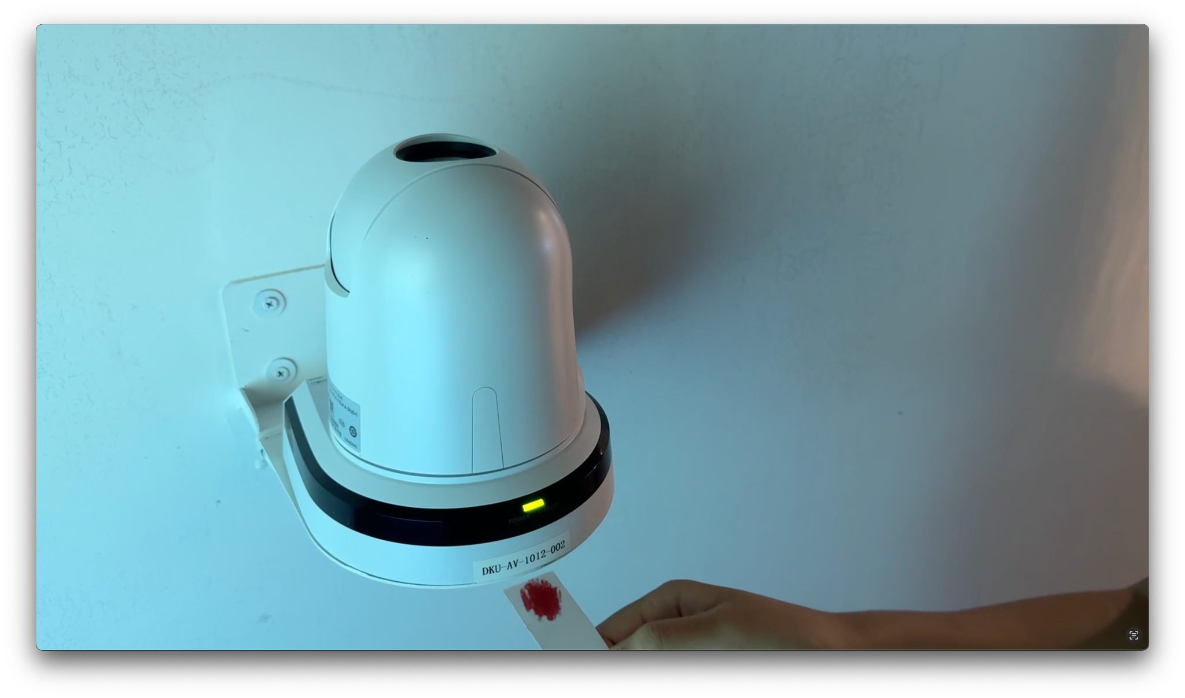

Example of Propaganda Video (similar to Project 2 ad)

**Contribution and Track Representation.**

Kami’s contribution builds on her digital media background by leading speculative and critical design across the scenario, presentation, dashboard/control interfaces, and accompanying media such as posters, news reports, and social feeds. She applies design and Human Computer Interaction principles to structure the functionality and usability of the dashboard and controls, ensuring an engaging simulation experience. She also develops video/graphic materials to expand the project’s narrative reach. Across these efforts, Kami highlights how digital culture, media communication, design practices, and algorithmic systems intersect to shape experience, creating an immersive environment that invites audiences to engage critically with the speculative world.

Yihan's contribution focused on embedding sociopolitical dimensions of the upgraded project. She will develop the expanded worldbuilding elements, such as class structure and the framing of Vitalis’s corporate role, and integrate policy implications into the simulation content. Conceptually, her track is represented in the project through the analysis of how policy justifies algorithmic authority and how citizens’ autonomy is curtailed by opaque infrastructures. Technically, she will contribute by designing the content that surfaces these issues within the dashboard and simulation: PSA messaging, ethical AI considerations, and scenario prompt engineering that highlight questions of accountability. Through these elements, her track ensures that the speculative world is not only technologically convincing but also socially and politically critical.

HCI is at the crux of human implants and Michael’s computer science background conceptually informs the way the chip manifests ‘growlers’. He also contributes to the technical aspects of refining the dashboard, especially in a software development capacity. Primarily, he edit the framework of the project with React, ensuring the dashboard is dynamic. In the updated project, he will add additional backend features to adapt the dashboard to be interfaced with by multiple users. Additionally, he will add algorithmic scoring features to ‘grade’ users on their control of the dashboard. His work abstracts the technical details from the user, ensuring that the dashboard is fluid and easy to use.